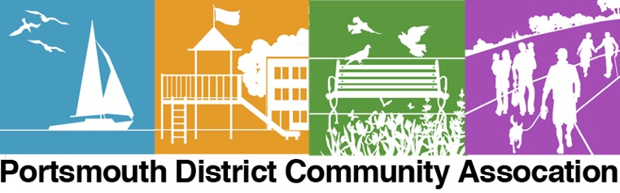
Join us for  Councillor Connect with Councillor Don Amos  and the  PDCA  Annual General Meeting  May 5, 2024, from 2 pm to 4 pm  Portsmouth Olympic Harbour Building  53 Yonge Street, Kingston  Doors open at 1:15 p.m. for membership registration and signup.  Councillor Connect with Don Amos  Guest Speakers:  Nathan Nesdoly,  District Climate Action Champion  Trevor Cellini,  Homes for Hero’s  Luke Follwell,  City Engineering Services, capital projects  Lanie Hurdle, City CAO  Extendicare facility update  AGM Agenda:  President’s Report  Financial Report  Association Activity Reports  Election of Executive Committee  Meet & Greet | Come and be a part of the Portsmouth District Community Association (PDCA), where you can be involved in the shaping and growth of our dynamic and beautiful district.  Sign up for our Newsletter and join our Facebook page to get the latest information about community activities and district businesses.  Membership: Single $10 Families $15  _________________________________________________  Food and cash donations will be collected to help address the growing needs in Kingston. Please bring donations.  ________________________________________
 |  | Find out what’s happening to our shorelines and keep informed on how you can support and preserve our waterfront.
 |  | Keep up-to-date on development proposals, City and Utilities Kingston activities, and public engagement opportunities across Portsmouth District.
 |  | We have some of the most beautiful and lively parks and gardens in the city of Kingston. Be a part of the planning and design of our green spaces.
 |  | Families, seniors, students and small businesses…we’re what makes our community grow and thrive. Join the PDCA!
Find out more by visiting our website: www.pdca.ca or email info@pdca.ca for more information

